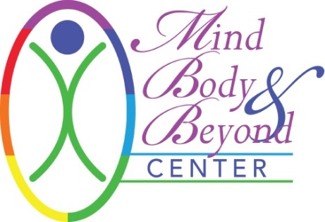

INFORMED CONSENT FOR ACUPUNCTURE
I hereby request and consent to the performance of acupuncture therapy and the procedures within the scope of the practice of acupuncture by the Licensed Acupuncturist named below or other licensed acupuncturists at Mind Body & Beyond.

I understand that methods of treatment may include, but are not limited to the following:

Acupuncture: insertion of sterilized, disposable needles through the skin into underlying tissues as specific points of the body.
Electro-acupuncture/MPS (Microcurrent Point Stimulation): acupuncture combined with mild electrical stimulation.
Cupping: a technique in which glass, bamboo, or plastic cups are therapeutically placed on the skin with a vacuum created by heat or other device.
Gua Sha: friction on an area of the body with a blunt, round instrument
Herbal Therapy: may be given in the form of pills, powders, tinctures, pastes, plasters, or other forms such as raw herbs to be cooked. Cooked herbs may be given to be used internally or externally. Herbal formulas include plant, shell, mineral, and animal sources and are considered traditionally safe in Chinese medicine. . I understand that the herbs may need to be prepared and the teas consumed according to the instructions provided orally and/or in writing. I will immediately notify my acupuncturist or Mind Body & Beyond staff of any unanticipated or unpleasant effects associated with the consumption of the herbs.
Infra-red lamp (TDP): therapeutic heat applied indirectly to the body.
Moxabustion: direct/indirect burning of moxa on acupoints
Tuina: an ancient massage used to treat a variety of common disharmonies.
Dietary Advice: based on Traditional Chinese Medical Theory.

Acupuncture is a generally safe method of treatment. I am aware that acupuncture is not a substitute for a medical examination and I will seek health care for those services. I accept that acupuncture promises no long-term results or that it will cure my health problems. Acupuncture may have some side effects/potential risks, including local discomfort, pain, numbness, tingling, infection, or blistering; temporary discoloration of the skin or bruising; nausea, abdominal discomfort, headache, lightheadedness, and possible acute aggravation of symptoms existing prior to treatment. All female patients must alert the practitioner if they know or suspect they are pregnant. While acupuncture and Oriental medicine is considered safe while pregnant, there are precautions and adjustments necessary during pregnancy although the rare risk of spontaneous miscarriage exists. Infection is another possible risk, although therapists contracted by Mind Body & Beyond always use sterile disposable needles and maintain a clean and safe environment. Bruising, burns and/or scarring are a potential risk of moxibustion and cupping. Some of the herbs and nutritional supplements may be toxic in large doses or may be inappropriate during pregnancy. Herbs, on occasion, can cause nausea, gas, stomachache, vomiting, headache, diarrhea, rashes, hives and tingling of the tongue. I will notify my acupuncturist or staff at Mind Body & Beyond if I have a health condition or if I am/become pregnant. The acupuncturist must be informed if you have a bleeding disorder or pacemaker. At any time during the session the client or acupuncturist is uncomfortable for any reason, they shall immediately say so. I realize that I am free to withdraw my consent and to discontinue participation in these procedures at any time.

I understand that the acupuncturist and Mind Body & Beyond shall not be liable for any damages arising from personal injuries sustained by a client during a acupuncture session and the client has this session at his/her own risk. Client assumes full responsibilities for any injuries or damages which may occur during and/or after
the session. I hereby fully and forever release and discharge Mind Body & Beyond and the acupuncturist, its assigns and agents from all claims, demands, damages, rights of action, present and future therein.

Children are not permitted in the procedure room and must have childcare provided for them during the treatment. Mind Body & Beyond does not provide childcare services.

Cancellation Policy: A 24-hour notice is required for cancellation of your appointment. After 1 (one) cancellation within 24 hours of your appointment, you will be billed the full amount for the 2nd cancellation. No call, no shows will not be rescheduled after their 2nd no call, no show unless the no call/no show has been paid in full.

I understand that a record will be confidentially kept of the health services provided to me and will not be released to others unless so directed by myself or my representative or if it is required by law.

Your signature (electronic and/or physical) below indicates that you have read this Agreement and voluntarily agree to the terms and consent to the above procedures.

Signature: Click here to enter text. Therapist/Technician: Click here to enter text.
Date: Click here to enter a date.

Signature of Patient Representative or Guardian: Click here to enter text.

Date: Click here to enter a date.

