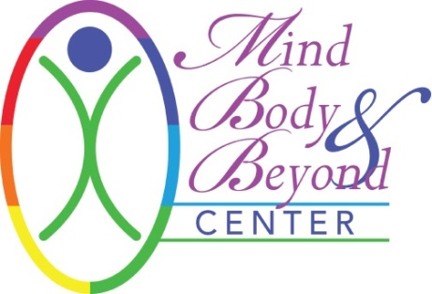

INFORMED CONSENT TO MASSAGE THERAPY TREATMENT

I hereby request and consent to the performance of massage therapy by the therapist/technician named below or other therapists/technicians at Mind Body & Beyond.

Massage in general provides benefits of stress reduction, relief from muscular tension, spasm, or pain, and it increases circulation and energy flow. I understand that massage therapists/technicians are not physicians and do not diagnose illness or disease or any other physical or mental disorder, perform any spinal manipulations, and do not prescribe any medical treatments. I am aware that therapeutic massage is not a substitute for a medical examination and I will seek health care for those services. I accept that massage promises no long-term results or that it will cure my health problems.

I understand that the massage therapist and Mind Body & Beyond shall not be liable for any damages arising from personal injuries sustained by a client during a massage and the client has this massage at his/her own risk. Client assumes full responsibilities for any injuries or damages which may occur during and/or after the massage. I hereby fully and forever release and discharge Mind Body & Beyond and the massage therapist, its assigns and agents from all claims, demands, damages, rights of action, present and future therein.

The therapist must be aware of all health conditions due to certain contraindications or cautions for massage. I have disclosed all such conditions. I will also update any changes to my health in future sessions.

If at any time during the massage the client or therapist/technician is uncomfortable for any reason, they shall immediately say so. I realize that I am free to discontinue my therapy/treatment at any time.

Sexual advances of any kind will not be tolerated. Children are not permitted in the massage room and must have childcare provided for them during the massage. Mind Body & Beyond does not provide childcare services.

Cancellation Policy: A 24-hour notice is required for cancellation of your massage appointment. After 1 (one) cancellation within 24 hours of your appointment, you will be billed for the 2nd cancellation. No call, no shows will not be rescheduled after their 2nd no call, no show.

All information will be kept strictly confidential and will remain with your therapist and Mind Body & Beyond unless written consent is given. Client contact notes will be retained by your therapist as required by law.

Your signature (electronic and/or physical) below indicates that you have read this Agreement and voluntarily agree to the terms.

Signature: ________________________________ Therapist/Technician: ____________________________
Date: _______________________________

