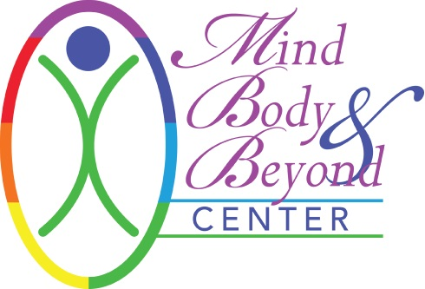
INFORMED CONSENT FORM FOR NUTRITIONAL COUNSELING

I hereby request and consent to the performance of nutritional counseling by the dietician named below or other dieticians at Mind Body & Beyond.

The consult will provide information and guidance about health factors within my own control: my diet, nutrition, and lifestyle. I understand Mind Body & Beyond’s contracted dieticians are not medical physicians- do not dispense medical advice, nor diagnose or treat any medical condition, but will provide nutritional support and nutrition education. They provide education to enhance my knowledge of health through the use of whole foods, dietary supplements, and emotional awareness. While nutritional and botanical support can be an important compliment to my medical care, I understand these services are not a substitute for medical care. Methods of nutritional evaluation or testing are intended as a guide to developing an appropriate health-supportive program for me and to monitor my progress in achieving my goals.

If the Client is under the care of a health care professional or currently uses prescription medications, the Client should discuss any dietary changes or potential dietary supplements use with his or her doctor, and should not discontinue any prescription medications without first consulting his or her doctor. The Client acknowledges that the care that they receive during their nutritional counseling sessions is separate from the care that they receive from any medical facility in that the nutritional counseling sessions are in no way intended to be construed as medical advice or care. The Client should continue regular medical supervision and care by their primary care physician.

I understand that the dieticians and Mind Body & Beyond shall not be liable for any damages arising from personal injuries sustained by a client during or after a session and the client has this session at his/her own risk. Client assumes full responsibilities for any injuries or damages which may occur during and/or after the session. I hereby fully and forever release and discharge Mind Body & Beyond and the dietician, its assigns and agents from all claims, demands, damages, rights of action, present and future therein.

The dietician must be aware of all health conditions due to certain contraindications or cautions for nutritional counseling. I have disclosed all such conditions. I will also update any changes to my health in future sessions. Children are not permitted in the room with the client and must have childcare provided for them during the session. Mind Body & Beyond does not provide childcare services.

Cancellation Policy: A 24-hour notice is required for cancellation of your appointment. After 1 (one) cancellation within 24 hours of your appointment, you will be billed for the 2nd cancellation. No call, no shows will not be rescheduled after their 2nd no call, no show.

All information will be kept strictly confidential and will remain with your dietician and Mind Body & Beyond unless written consent is given. Client contact notes will be retained by your dietician as required by law.

Your signature (electronic and/or physical) below indicates that you have read this Agreement and voluntarily agree to the terms.
Signature:___________________________________ Dietician:____________________________________
Date: _____________________________

