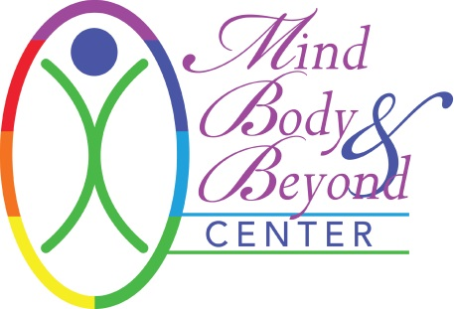

INFORMED CONSENT FOR PERSONAL TRAINING AND/OR YOGA

I hereby request and consent to personal training and/or yoga by the therapist/technician/instructor named below or other therapists/technicians/instructors at Mind Body & Beyond.

I understand that this personal training and/or movement program may include exercises to build the cardio respiratory system (heart and lungs), the musculoskeletal system, (which involves muscular endurance, strength and overall flexibility), and to improve body composition (increasing muscle and bone and decreasing body fat).

I understand that there risks from personal training and movement programs including but not limited to blood pressure, heart attacks, muscular strain, pain and injury. I realize that it is necessary for me to report, promptly, any signs and/or symptoms indicating abnormalities or distress. I know that if there are any questions about the procedures or methods used during a session, I should ask my instructor. If I have any doubts, concerns or questions I should ask for further explanation. I am also aware that I may decide to discontinue a session at any time should I be in any distress.

I understand that the personal trainer, instructor and Mind Body & Beyond shall not be liable for any damages arising from personal injuries sustained by a client during personal training and/or yoga and the client does this training at his/her own risk. Client assumes full responsibilities for any injuries or damages which may occur during and/or after training. I hereby fully and forever release and discharge Mind Body & Beyond and the personal trainer/instructor, its assigns and agents from all claims, demands, damages, rights of action, present and future therein.

Children are not permitted in the personal training/yoga room and must have childcare provided for them during their session. Mind Body & Beyond does not provide childcare services.

Cancellation Policy: A 24-hour notice is required for cancellation of your appointment. After 1 (one) cancellation within 24 hours of your appointment, you will be billed for the 2nd cancellation. No call, no shows will not be rescheduled after their 2nd no call, no show.

I understand and warrant, release and agree that I am in good physical condition and that I have no disability, impairment or ailment preventing me from engaging in active or passive exercise that will be detrimental to myself other than those items fully discussed and disclosed in writing.

All information will be kept strictly confidential and will remain with your therapist and Mind Body & Beyond unless written consent is given. Client contact notes will be retained by your therapist as required by law.

Your signature (electronic and/or physical) below indicates that you have read this Agreement and voluntarily agree to the terms.

Signature: ____________________________________ Trainer: _________________________________
Date: ________________________________

