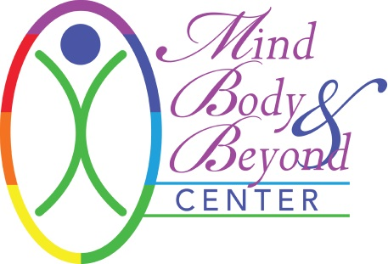

INFORMED CONSENT FOR SPIRITUAL HEALING

I hereby request and consent to spiritual healing techniques by the healer named below or other healers at Mind Body & Beyond.

I am aware that sessions provide various sensations during and after a session depending upon the topic or issue covered. Clients may sometimes experience an increased flow of energy throughout their body and personal space creating an increased sense of well-being. Alternatively, energy work may bring about the release of old emotions such as grief, sadness or anger as part of the healing process. Clients often find it appropriate to relax right after a session and allow the integration of the energy work to continue. Drinking water and relaxing allows the body to eradicate old toxins and energy and provide the body to integrate the energetic alterations.

I understand that Energy Healing Practitioners are generally not recognized by American Medical Societies and are not practicing or performing these spiritual techniques as conventional Licensed Health Caregivers. Any consultations or services provided by our spiritual healers do not interfere or replace the use of conventional medical care provided by Licensed Health Caregivers and do not intend to diagnose physical or medical conditions nor prescribe treatments to prevent or cure any disease, psychological conditions, illness, or symptoms. No claims of miracles or cures have been made, expressed, or implied.

I understand that the spiritual healer and Mind Body & Beyond shall not be liable for any damages arising from psychological or personal injuries sustained by a client during spiritual healing and that the client enters his/her sessions at his/her own risk. I realize that I am free to discontinue a session at any time for any reason. Client assumes full responsibility for any injuries or damages which may occur during and/or after the session(s). I hereby fully and forever release and discharge Mind Body & Beyond and the spiritual healer, its assigns and agents from all claims, demands, damages, rights of action, present and future therein.

Children are not permitted in the room during the session and must have childcare provided for them during their session. Mind Body & Beyond does not provide childcare services.

Cancellation Policy: A 24-hour notice is required for cancellation of your appointment. After 1 (one) cancellation within 24 hours of your appointment, you will be billed for the 2nd cancellation. No call, no shows will not be rescheduled after their 2nd no call, no show.

All information will be kept strictly confidential and will remain with your therapist and Mind Body & Beyond unless written consent is given. Client contact notes will be retained by your therapist as required by law.

Your signature (electronic and/or physical) below indicates that you have read this Agreement and voluntarily agree to the terms.

Signature: ___________________________________ Healer: _________________________________

Date: ______________________________

